**CUSTOMER SUPPORT PORTAL**

**USING SALESFORCE**

This document outlines the development and implementation of the Salesforce Customer Support Portal, designed to enhance our internal customer support operations. The portal aims to provide a centralized, efficient, and user-friendly platform for employees to resolve issues related to our products quickly and effectively. It includes detailed descriptions of the portal's key features, objectives, benefits, and integration capabilities.

**Prepared by,**

**NANTHAKUMAR A**

**Create / Change History**

|  |  |  |  |
| --- | --- | --- | --- |
| **Version** | **Date** | **Author** | **Description of change** |
| 1.0 | 12.06.2024 | Nanthakumar | Initial draft created |
|  |  |  |  |

**Approval History**

|  |  |  |  |  |
| --- | --- | --- | --- | --- |
| **Version** | **Date** | **Name** | **Designation** | **Approval Status** |
| 1.0 | 19.06.2024 | Awanish Kumar | CTO | Approved |
|  |  |  |  |  |

**Table of Contents**

1. Introduction 5

1.1. Key Objectives 6

2. Scope of the project 7

2.1. Objectives 7

2.1.1. Primary Objective 7

2.1.2. Secondary Objectives 7

2.2. Deliverables 7

2.3. In Scope 7

2.4. Out of Scope 8

2.5. Key Integrations 9

2.5.1. Customer Relationship Management (CRM) 9

2.5.2. Email and Communication Tools 9

2.5.3. Knowledge Management Systems 10

2.5.4. Live Chat and Messaging Tools 10

2.5.5. Analytics and Reporting Tools 11

2.5.6. Third-Party Tools 11

2.6. Service Level Agreement (SLA) 12

2.6.1. Overview 12

2.6.2. SLA Objectives 12

2.6.3. SLA Metrics 12

2.6.4. Priority Levels 14

2.6.5. Monitoring and Reporting 14

2.6.6. Penalties and Incentives 15

2.6.7. Customer Communication 16

2.7. Stakeholders 16

2.7.1. Primary Stakeholders 16

2.7.2. Secondary Stakeholders 17

3. Architecture and Workflow 17

3.1. Architecture 17

3.2. Process flow/ Workflow 19

3.2.1. Pre-User login admin process 19

3.2.2. Application Flow 21

4. Technologies Used 25

5. Constrains 26

6. Conclusion 29

# **Introduction**

The Salesforce Customer Support Portal is being developed to enhance the efficiency and effectiveness of our internal support services. This portal will serve as a centralized platform for our employees to access support resources, submit and track support cases, and interact with support teams. In today's fast-paced business environment, quick and accurate resolution of internal issues is crucial for maintaining productivity and ensuring smooth operations. This document outlines the objectives, key features, and benefits of the Salesforce Customer Support Portal, aiming to provide a comprehensive solution to streamline internal customer support and improve overall employee satisfaction.

## **Key Objectives**

* **Rapid Issue Resolution**: Enable employees to identify and resolve issues quickly through a comprehensive, self-service knowledge base and efficient case management system.
* **Enhanced Self-Service Options**: Provide employees with a robust repository of FAQs, chatbots, troubleshooting guides, and best practices to empower them to resolve common issues independently.
* **Efficient Case Management**: Streamline the submission, routing, and tracking of support cases to ensure timely and effective resolution.
* **Unified Support Channels**: Integrate multiple support channels (chat, email, phone, forums) into a single platform for a consistent support experience.
* **Personalized Support Experience**: Leverage employee data to deliver personalized support interactions and relevant solutions.
* **Comprehensive Reporting and Analytics**: Offer detailed dashboards and reports to monitor support performance and identify areas for improvement.

# **Scope of the project**

## **Objectives**

### **Primary Objective:**

* Develop a comprehensive Salesforce Customer Support Portal to enhance customer service capabilities, improve user experience, and streamline support operations.

### **Secondary Objectives:**

* Enhance customer satisfaction and loyalty.
* Reduce the workload on support agents through self-service options.
* Improve the accuracy and speed of issue resolution.
* Provide insightful analytics and reporting to track support performance and customer issues.

## **Deliverables**

* A fully functional Salesforce Customer Support Portal.
* Integration with the existing CRM system.
* Migration of existing support data to the new portal.
* A knowledge base and FAQ section.
* User manuals and training materials for both customers and support agents.

## **In Scope**

* **Development and Customization**:
  + Design and development of the Salesforce Customer Support Portal interface.
  + Customization of the portal to meet specific business requirements.
* **Integration**:
  + Integrating the portal with the existing Customer Relationship Management (CRM) system.
  + Ensuring seamless data flow between the portal and other related systems.
* **Data Migration**:
  + Migrating existing support data to the new platform.
  + Ensuring data integrity and accuracy during the migration process.
* **Knowledge Base and FAQs**:
  + Creating a comprehensive knowledge base for customers to access self-help resources.
  + Developing a FAQ section to address common customer queries.
* **Training**:
  + Providing training sessions for support staff on how to use the new portal managements.
  + Developing training materials and user guides for customers.

## **Out of Scope**

* **Non-Support Related Functionalities**:
  + Development of functionalities unrelated to customer support, such as sales or marketing features.
* **Third-Party Application Integrations**:
  + Integrations with third-party applications not related to the customer support function.
* **Customizations Beyond Defined Requirements**:
  + Any customizations or enhancements that are not aligned with the defined project objectives and requirements.

## **Key Integrations**

### **Customer Relationship Management (CRM):**

* **Salesforce CRM Integration:**

**Data Synchronization:** Automatically sync customer data, support cases, and interaction history between the portal and Salesforce CRM.

**Unified Customer View:** Provide support agents with a 360-degree view of the customer, including past interactions, purchase history, and support cases.

**Automated Updates:** Ensure that any changes in customer information or case status are reflected in real-time across all systems.

### **Email and Communication Tools:**

* **Email Integration:**

**Case Creation and Updates:** Allow customers to create and update support cases via email. Automatically convert emails into support tickets within the portal.

**Notification System:** Send automated email notifications to customers and support agents regarding case status updates, responses, and resolution.

**Email Tracking:** Track email interactions between customers and support agents for a comprehensive case history.

### **Knowledge Management Systems:**

* **Salesforce Knowledge Integration:**

**Centralized Knowledge Base:** Integrate the Salesforce Knowledge module to provide a centralized repository of articles, FAQs, and troubleshooting guides.

**Contextual Search:** Enable contextual search capabilities within the portal to help customers quickly find relevant information.

**Feedback Loop:** Allow customers to rate and provide feedback on knowledge articles to continuously improve content quality.

### **Live Chat and Messaging Tools:**

* **Salesforce Live Agent Integration:**

**Real-Time Support:** Embed live chat functionality within the portal for real-time customer support.

**Chat Transcripts:** Automatically save chat transcripts to the corresponding support case in Salesforce CRM for future reference.

**Chat Bots:** Utilize AI-powered chatbots for initial customer interaction and to handle common inquiries, escalating to live agents as needed.

### **Analytics and Reporting Tools:**

* **Salesforce Einstein Analytics Integration:**

**Performance Dashboards:** Integrate with Einstein Analytics to provide real-time dashboards and reports on support metrics, such as case resolution times, customer satisfaction scores, and agent performance.

**Predictive Insights:** Use predictive analytics to identify trends and proactively address potential issues.

**Custom Reports:** Allow support managers to create custom reports to analyse specific aspects of support operations.

### **Third-Party Tools:**

* **Integration with Third-Party Applications:**

**API Integration:** Utilize APIs to connect with third-party applications, such as external ticketing systems, billing platforms, and customer feedback tools.

**Data Import/Export:** Facilitate data import and export between the portal and external systems to ensure data consistency and accuracy.

**Webhooks:** Implement Webhooks for real-time data exchange and triggering of automated workflows based on specific events.

## **Service Level Agreement (SLA)**

### **Overview**

The Service Level Agreement (SLA) outlines the performance and quality standards that the Customer Support Portal must meet to ensure a high level of customer satisfaction and efficient support operations. SLAs define the expected response and resolution times for different types of support requests, ensuring that customers receive timely and effective assistance.

### **SLA Objectives**

The primary objectives of the SLA are to:

1. **Ensure Timely Support:** Guarantee prompt response and resolution of customer inquiries and issues.
2. **Enhance Customer Satisfaction:** Maintain high levels of customer satisfaction by meeting or exceeding service expectations.
3. **Measure Performance:** Provide measurable targets for support performance and accountability.
4. **Drive Continuous Improvement:** Identify areas for improvement and implement changes to enhance support efficiency and effectiveness.

### **SLA Metrics**

1. **Response Time:**
   * **Definition:** The time taken to acknowledge and respond to a customer's support request after it is submitted.
   * **Targets:**
     + **High Priority Cases:** Response within 1 hour.
     + **Medium Priority Cases:** Response within 4 hours.
     + **Low Priority Cases:** Response within 8 hours.
2. **Resolution Time:**
   * **Definition:** The time taken to resolve a customer's support request from the moment it is submitted.
   * **Targets:**
     + **High Priority Cases:** Resolution within 4 hours.
     + **Medium Priority Cases:** Resolution within 24 hours.
     + **Low Priority Cases:** Resolution within 72 hours.
3. **First Contact Resolution (FCR) Rate:**
   * **Definition:** The percentage of support requests resolved during the first interaction with the customer.
   * **Target:** Achieve an FCR rate of 85%.
4. **Customer Satisfaction (CSAT) Score:**
   * **Definition:** The average satisfaction score provided by customers after their support cases are resolved.
   * **Target:** Maintain a CSAT score of 90% or higher.
5. **Escalation Rate:**
   * **Definition:** The percentage of support cases that are escalated to higher levels of support.
   * **Target:** Keep the escalation rate below 10%.
6. **Average Handle Time (AHT):**
   * **Definition:** The average time spent by support agents on handling a support request.
   * **Target:** Maintain an AHT of 30 minutes or less.

### **Priority Levels**

Support requests will be categorized into different priority levels based on the severity and impact of the issue. The following priority levels will be used:

1. **High Priority:**
   * **Criteria:** Issues causing critical business impact, such as system outages or major functionality failures.
   * **Examples:** System down, data loss, security breaches.
2. **Medium Priority:**
   * **Criteria:** Issues causing significant impact but with workarounds available.
   * **Examples:** Performance degradation, partial system functionality loss.
3. **Low Priority:**
   * **Criteria:** Issues causing minimal impact, cosmetic problems, or general inquiries.
   * **Examples:** Minor UI issues, general usage questions, enhancement requests.

### **Monitoring and Reporting**

To ensure compliance with the SLAs, the following monitoring and reporting mechanisms will be implemented:

1. **Real-Time Monitoring:**
   * **Dashboard:** Implement real-time dashboards within Salesforce to monitor SLA metrics and track the status of support requests.
   * **Alerts:** Set up automated alerts to notify support managers of SLA breaches or potential issues.
2. **Regular Reporting:**
   * **Weekly Reports:** Generate weekly reports summarizing SLA performance, including response and resolution times, CSAT scores, and escalation rates.
   * **Monthly Reviews:** Conduct monthly reviews with key stakeholders to discuss SLA performance and identify areas for improvement.
3. **Performance Analysis:**
   * **Root Cause Analysis:** Perform root cause analysis for SLA breaches to identify underlying issues and implement corrective actions.
   * **Continuous Improvement:** Use performance data to drive continuous improvement initiatives and optimize support processes.

### **Penalties and Incentives**

To enforce SLA compliance, the following penalties and incentives will be established:

1. **Penalties:**
   * **SLA Breach Penalties:** Implement penalties for repeated SLA breaches, such as reduced support fees or service credits.
   * **Escalation Procedures:** Define escalation procedures for critical SLA breaches, involving higher management and priority handling.
2. **Incentives:**
   * **Performance Bonuses:** Offer performance bonuses to support agents and teams that consistently meet or exceed SLA targets.
   * **Recognition Programs:** Implement recognition programs to acknowledge and reward high-performing support agents.

### **Customer Communication**

Clear and proactive communication with customers is essential for managing expectations and maintaining satisfaction. The following communication strategies will be used:

1. **Acknowledgment Messages:**
   * **Immediate Confirmation:** Send immediate confirmation messages to customers upon receipt of their support requests.
   * **Case Details:** Provide case details, including the assigned case number, priority level, and expected response time.
2. **Status Updates:**
   * **Regular Updates:** Provide regular status updates to customers on the progress of their support requests.
   * **Escalation Notifications:** Inform customers promptly if their cases are escalated to higher levels of support.
3. **Resolution Communication:**
   * **Resolution Confirmation:** Notify customers when their support requests are resolved, including details of the resolution.
   * **Feedback Request:** Request feedback from customers on their support experience to measure satisfaction and identify improvement areas.

## **Stakeholders**

### **Primary Stakeholders:**

* **Customers**: End-users who will access the portal for support services.
* **Support Agents**: Staff who will use the portal to manage customer issues and provide resolutions.
* **Management**: Executives and managers interested in performance metrics and customer satisfaction.

### **Secondary Stakeholders:**

* **IT Team**: Responsible for technical implementation and maintenance.
* **Sales Team**: Interested in customer feedback and satisfaction for sales insights.

# **Architecture and Workflow**

## **Architecture**

* **User Interface Layer**
* **Customer Portal / Web Interface**

Used for Connect, My Cases (dashboard), and FAQs access.

* **Front-End Layer**
* **Salesforce Community Cloud**

Hosts the customer portal where users can view their cases, access FAQs, and interact with the AI chatbot.

* **AI and Chatbot Layer**
* **Salesforce Einstein Bots**

Provides AI-based self-servicing chat for initial query handling.

* **Integration with Live Agent**

Connects unresolved queries to a human support team member.

* **Service Layer**
* **Salesforce Service Cloud**

Manages case submissions, tracking, and updates.

* **Case Management**

Handles the lifecycle of cases (All Cases, Pending Cases, Resolved Cases, and Closed Cases).

* **Knowledge Base (KB)**

Repository of FAQs and articles.

* **Backend Integration Layer**
* **Salesforce CRM**

Stores customer information and case histories.

* **Middleware / API Gateway**

Connects Salesforce to other backend systems as needed.

* **Database Layer**
* **Salesforce Database**

Primary database for storing all case and customer data.

* **Analytics and Reporting Layer**
* **Salesforce Einstein Analytics**

Provides insights and analytics on support operations and case data.

* **Security Layer**
* **Salesforce Shield**

Enhances data security with encryption and monitoring.

* **Identity and Access Management**

Controls user access and permissions.

## **Process flow/ Workflow**

### **Pre-User login admin process**

#### **Step 1: Create Contact for Customer**

* **Objective**: Admin creates a contact record for the customer in Salesforce.

1. **Admin logs into Salesforce.**
2. **Navigate to the Accounts tab**:
   * Locate and select the relevant account for the customer.
3. **Create a new contact**:
   * Under the selected account, go to the Contacts related list.
   * Click on **New Contact**.
   * Fill in the required contact details
   * Click **Save**.

#### **Step 2: Convert Contact into Customer User**

* **Objective**: Admin converts the newly created contact into a customer user.

1. **Open the contact record** that was just created.
2. **Enable Customer User**:
   * Click on the **Manage External User** button (label may vary, e.g., **Enable Customer User**).
   * Select **Enable Customer User** from the dropdown menu.
3. **Fill in user details**:
   * Complete the required fields for the user profile, including assigning a username and profile (e.g., Customer Community User).
4. **Save the user record**:
   * Click **Save**. An email will be automatically sent to the customer with their login details.

#### **Step 3: Customer Receives Email with Login Details**

* **Objective**: Customer receives an email with login credentials and instructions.

1. **Customer opens the email** sent from Salesforce.
2. **Email contents**:
   * The email includes the username and a link to set the password for the first-time login.

#### **Step 4: Customer Sets Password for First Login**

* **Objective**: Customer sets a password for their new account.

1. **Customer clicks on the link** provided in the email.
2. **Set a new password**:
   * The link directs the customer to the Salesforce password setup page.
   * Enter the username (if not pre-filled).
   * Set and confirm the new password, following the password policy.
3. **Complete password setup**:
   * Click **Save** or **Submit** to finalize the password setup.

#### **Step 5: Customer Logs into the Portal**

* **Objective**: Customer logs into the Customer Support Portal using their new credentials.

1. **Navigate to the login page** of the Customer Support Portal.
2. **Enter login details**:
   * Enter the username and newly set password.
3. **Login**:
   * Click **Login** to access the portal.

### **Application Flow**

1. **Start**
   * The process begins when a customer identifies an issue.
2. **Customer Gets an Issue**
   * The customer recognizes that they have an issue that needs support.
3. **Form Submission**
   * The customer fills out and submits a form detailing their issue.
4. **Case Creation**
   * The system checks if the case can be created with the provided information.
   * If yes, proceed to case assignment.
   * If no, the customer is notified to submit the form again.
5. **Department Assignment**
   * The case is checked for the appropriate agent based on the details provided.
   * The case is assigned to the relevant queue.
   * The support team is notified via email about the new case.
6. **Customer Dashboard**
   * The customer can view their case details and status on their dashboard.
7. **Support Team Assignment and Action**
   * A support team member logs in and is assigned the case.
   * The support team member begins working on the case.
   * Critical issues are immediately notified to the customer.
8. **Case Resolution Process**
   * The support team member works to resolve the case.
   * If more details are needed, the customer is contacted.
9. **SLA (Service Level Agreement) Violation Check**
   * The system checks if there is any SLA violation.
   * If there is a violation, the customer is notified and preventive measures are taken.
10. **Case Status Monitoring**
    * The system continuously monitors the status of the case to determine if it is resolved, closed, or needs to be re-opened.
11. **Resolution Confirmation and Feedback**
    * If the case is resolved, the customer confirms the resolution.
    * The customer is asked to provide feedback on the solution and service.
    * If the case needs to be re-opened, it is reviewed and reworked as necessary.
12. **Final Steps**
    * Once resolved and feedback is collected, the case is documented.
    * The support team member logs out.
    * The process ends.

**Key Decision Points**

1. **Case Creation Decision**
   * Determines whether the provided information is sufficient to create a case.
2. **Department Identification**
   * Assigns the case to the correct department based on the issue details.
3. **Case Resolution Check**
   * Checks if the case has been resolved or needs additional information.
4. **SLA Violation Check**
   * Monitors if there is any SLA violation during the resolution process.
5. **Case Status Monitoring**
   * Continuously checks the status of the case to ensure it is being handled properly.

**Notifications and Feedback**

* The customer is notified at key stages of the process, including case creation, critical issues, SLA violations, and resolution.
* Feedback is collected from the customer to improve service quality.

**Flow chart**

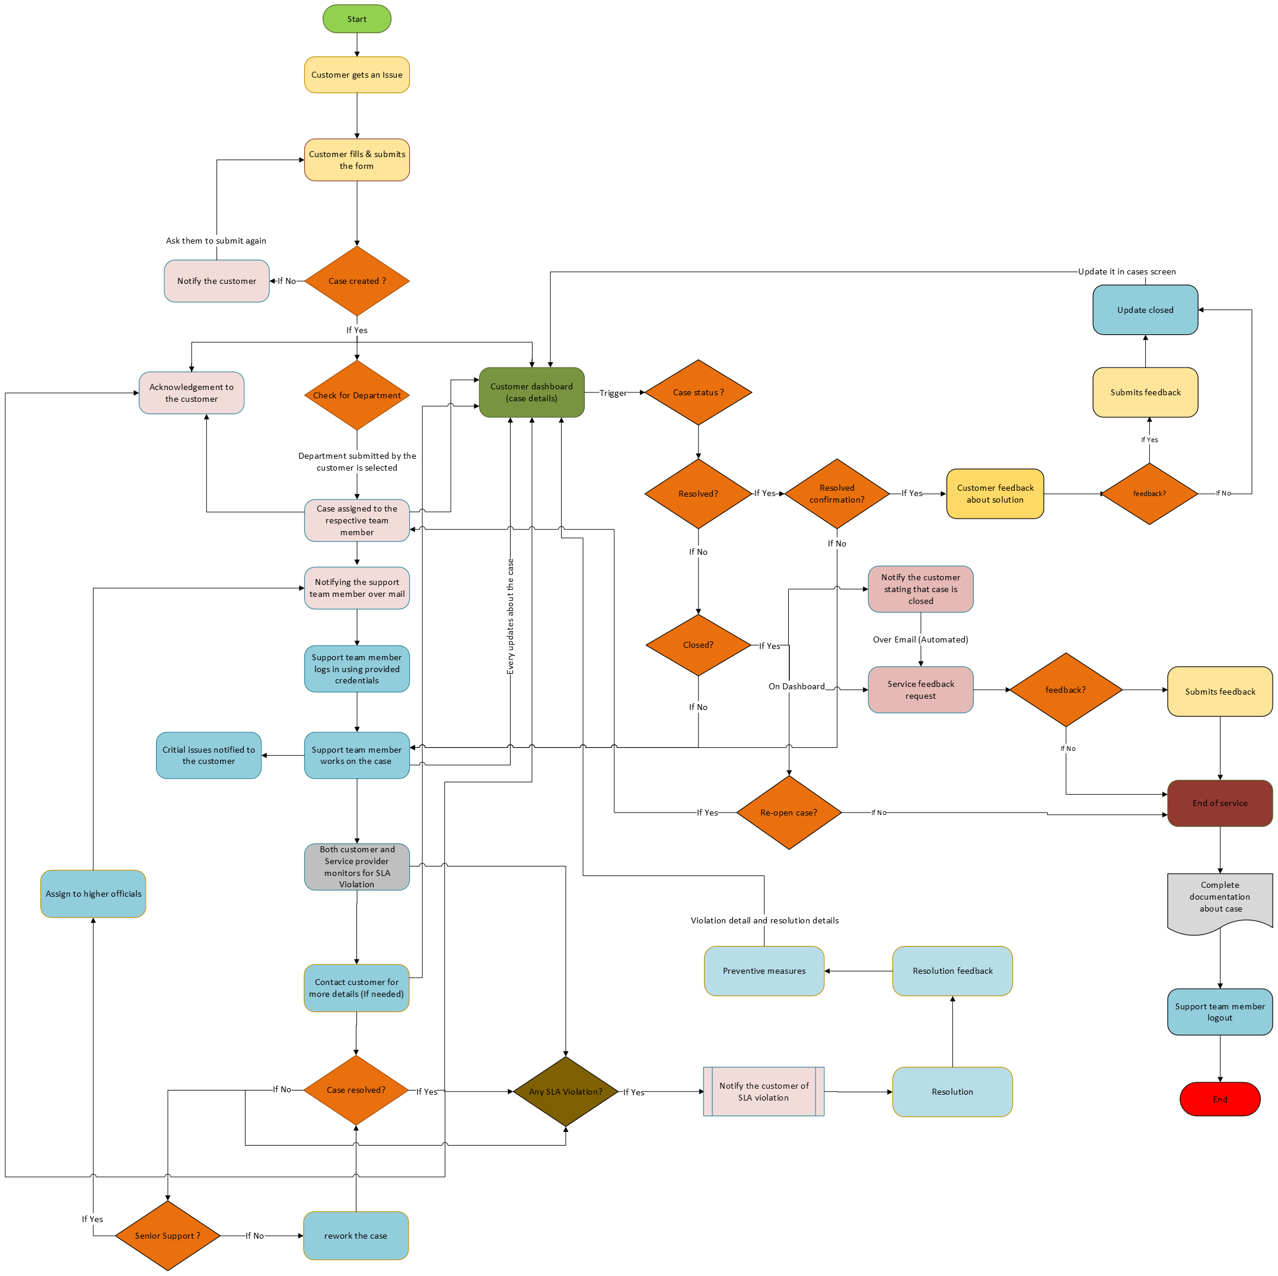

# **Technologies Used**

* **Salesforce**: Primary platform for CRM and customer support functionalities.
  + **Salesforce Community Cloud**: For building and managing the customer support portal.
  + **Salesforce Service Cloud**: For managing support cases and customer interactions.
* **Email Service**: For sending automated emails to customers (e.g., Salesforce Email Templates, Marketing Cloud).
* **APIs**:
  + **Salesforce APIs**: For integrating with external systems and managing data flows.
* **Frontend Technologies**:
  + **Lightning Web Components (LWC)**: For building responsive and interactive user interfaces within Salesforce.
  + **HTML/CSS**: For styling and structuring the portal pages.
* **Analytics and Reporting**:
  + **Salesforce Reports and Dashboards**: For generating insights and tracking performance metrics.

# **Constrains**

1. **Budget Constraints**

* **Description**: Limited budget allocation for the development, implementation, and maintenance of the Salesforce Customer Support Portal.
* **Impact**: May restrict the scope of the project, necessitate prioritization of features, or require cost-saving measures.

1. **Timeline Constraints**

* **Description**: Fixed project deadlines or timeframes for the deployment of the support portal.
* **Impact**: May limit the amount of time available for development, testing, and user training, potentially affecting the quality or completeness of the final product.

1. **Resource Constraints**

* **Description**: Limited availability of skilled resources, including developers, administrators, and support staff.
* **Impact**: Could result in delays, resource bottlenecks, or increased workload for existing team members, affecting project timelines and quality.

1. **Technical Constraints**

* **Description**: Technical limitations or dependencies related to the Salesforce platform or other integrated systems.
* **Impact**: May restrict the customization options, integration capabilities, or performance optimization of the support portal, requiring workarounds or compromises.

1. **Regulatory Compliance**

* **Description**: Compliance requirements related to data privacy, security, and industry regulations (e.g., GDPR, HIPAA).
* **Impact**: Must ensure that the support portal meets all regulatory standards and requirements, potentially adding complexity or constraints to the project.

1. **Legacy Systems Integration**

* **Description**: Integration with existing legacy systems, databases, or third-party applications.
* **Impact**: Compatibility issues, data migration challenges, or system limitations may arise, requiring additional time and resources to address.

1. **User Adoption**

* **Description**: Resistance to change or lack of user buy-in for the new support portal among employees.
* **Impact**: Could result in low user adoption rates, reduced utilization of the portal, or the need for extensive training and change management efforts.

1. **Scalability and Performance**

* **Description**: Requirements for scalability and performance under high load conditions or increasing user volumes.
* **Impact**: Must ensure that the support portal can handle anticipated growth and usage without degradation in performance or system stability.

1. **Vendor Lock-in**

* **Description**: Dependency on Salesforce as the chosen platform for the support portal.
* **Impact**: Limited flexibility to switch to alternative solutions or vendors in the future, potentially increasing long-term costs or constraints.

1. **Geographical Constraints**

* **Description**: Geographic distribution of users or regulatory requirements related to data residency.
* **Impact**: Must ensure compliance with regional data privacy laws and consider network latency or performance issues for geographically dispersed users.

# **Conclusion**

The implementation of a customer support portal in Salesforce represents a significant enhancement in customer service capabilities. This platform streamlines customer interactions by providing a centralized, accessible, and efficient solution for addressing support inquiries and issues. Key benefits include:

1. **Improved Customer Experience**: Customers gain 24/7 access to support resources, enabling them to find answers to common questions and track their service requests independently.
2. **Enhanced Agent Efficiency**: Support agents benefit from a unified view of customer interactions and histories, allowing for faster and more accurate issue resolution.
3. **Scalability and Flexibility**: Salesforce's robust infrastructure supports the growing needs of businesses, accommodating increased volumes of support requests without compromising service quality.
4. **Data-Driven Insights**: The platform's analytics capabilities provide valuable insights into customer behaviour and service performance, helping organizations identify areas for improvement and optimize their support strategies.

Overall, a customer support portal in Salesforce not only elevates the customer support experience but also drives operational efficiencies and strategic insights, positioning businesses for sustained success and customer satisfaction.